- Aligning displays
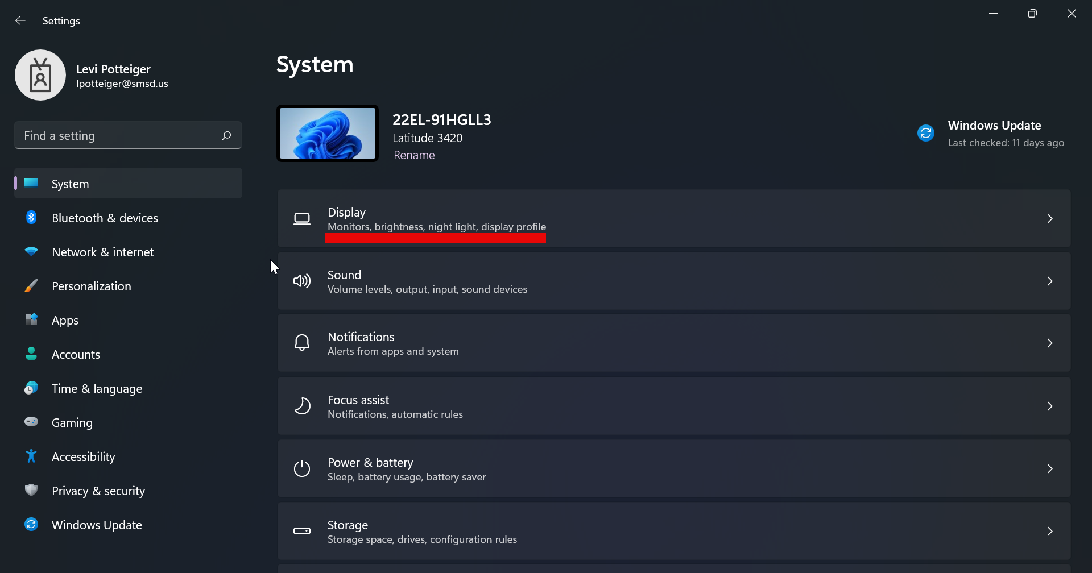
Please start by opening the Start Menu (Clicking the Windows icon on your taskbar or tapping the Windows key between “fn” and “alt”). From there either click the Settings icon (the cog wheel) or search for “settings” and open the application. From there the first option on the list should be “Display”, click it to enter your Display settings.
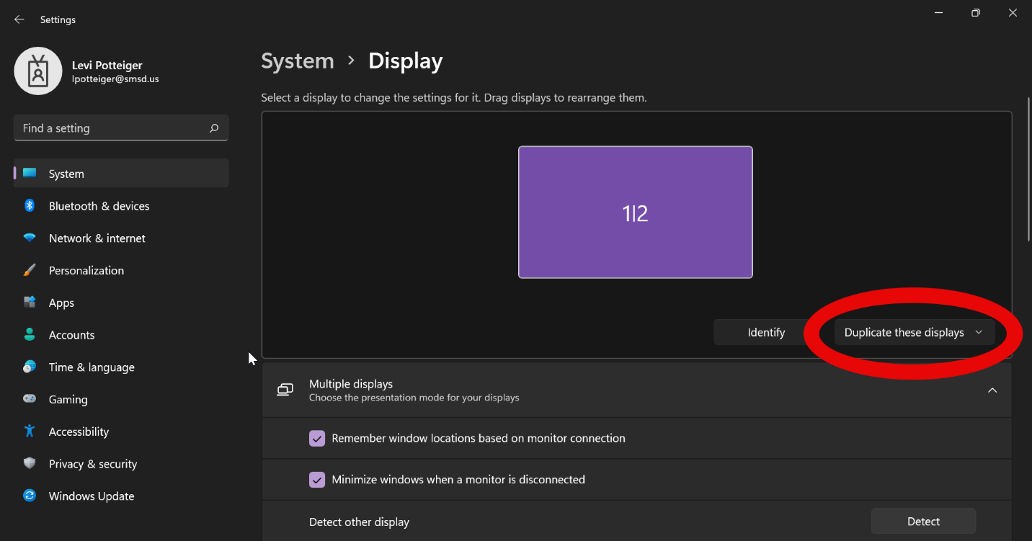
When you first plug into your dock and get to display settings, you will likely see this. If you have three displays plugged in and powered on (Laptop, Monitor, and likely a Smart Board), please select “Duplicate these displays” and change that to “Extend these displays”. This can prompt your laptop to recognize all of your displays as being connected, and gives a good starting point to customize your settings to fit what you want.

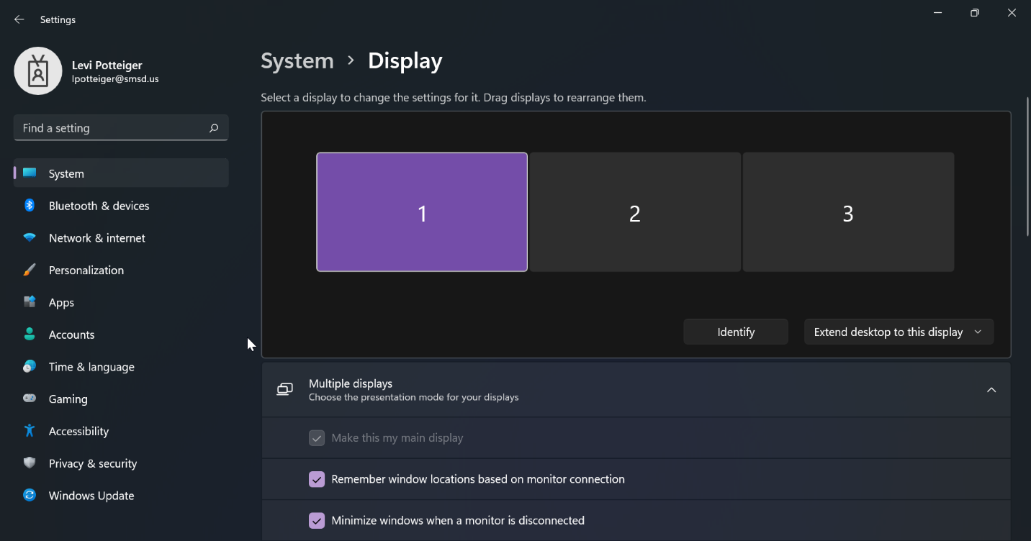
Once you’ve extended displays, or if your laptop was extending them by default, you should see something like this, obviously only showing two displays if you only have two displays.
From here, you will want to click “Identify” right next to where you extended your display. This will pop up a number on each screen. This number correlates to the displays in the arrangement panel. Your laptop should always be 1 assuming it is open and you’re using its screen.

You are going to want to rearrange displays in the display arrangement panel to try and match what is in the real world. If your laptop is to the left of the display on your desk, make sure display 1 is to the left of the numbered panel that your desk monitor is showing, if it’s to the right, move it to the right. Once you have the displays positioned where you want, click apply.

An application window can be moved from one screen to another by simply clicking the top bar and dragging it out of one display and onto the next. This follows the display configuration you setup.

- Main displays and duplicated displays
Once you have your displays aligned as you like, you can setup a main display and or duplicating displays if you’d like.

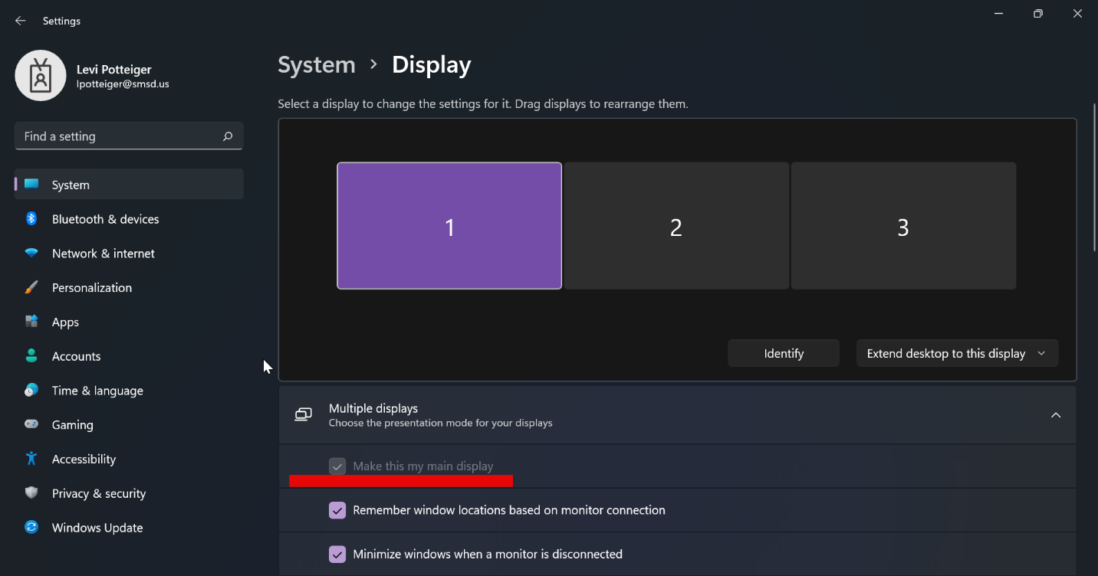
The main display is what it sounds like. It is the display your computer prioritizes. Applications will typically launch on your main display and it is the display your desktop icons will typically pop up on. This can be set incredibly easily. Simply select the display you’d like as the primary, click the box below the arrangement panel labeled “Multiple Displays” to open it, and click the check box next to “Make this my main display”

Duplicating specific displays is an incredibly convenient feature for teachers with Smart Boards/TVs or anyone with a display that will regularly be showing something to someone else rather than the user. For a teacher I recommend duplicating one of your displays with the smart board, which will allow you one display for privacy (for emails, grades, etc.) and one display duplicated onto the Smart Board, making it more convenient to use it from your desk. This can be done by highlighting one of the displays you’d like duplicated and clicking the dropdown shown. From there simply select which display you’d like to pair with the selected display. Duplicated displays can be rearranged as desired.

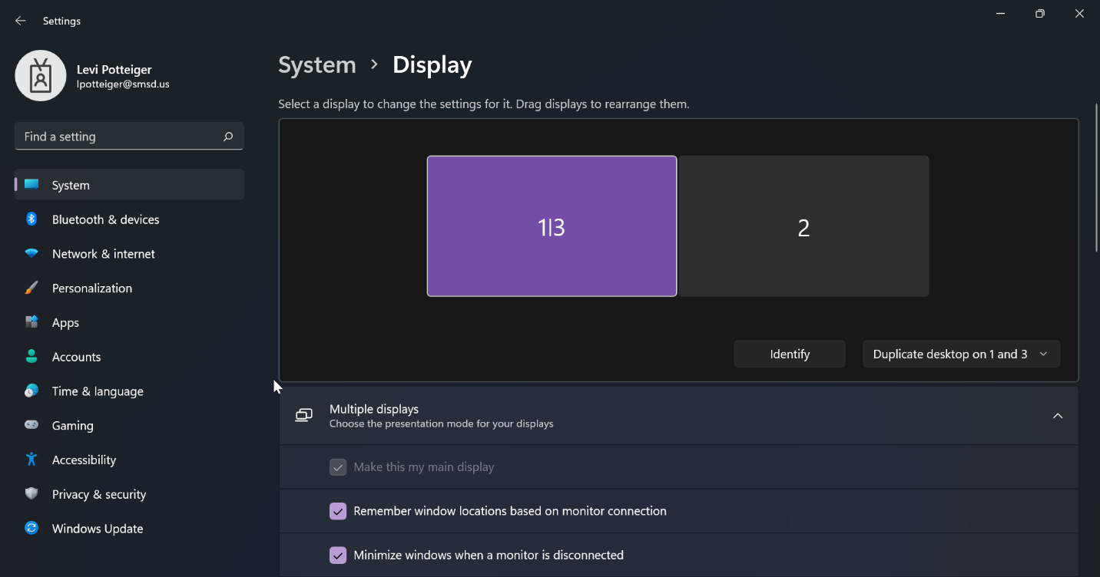
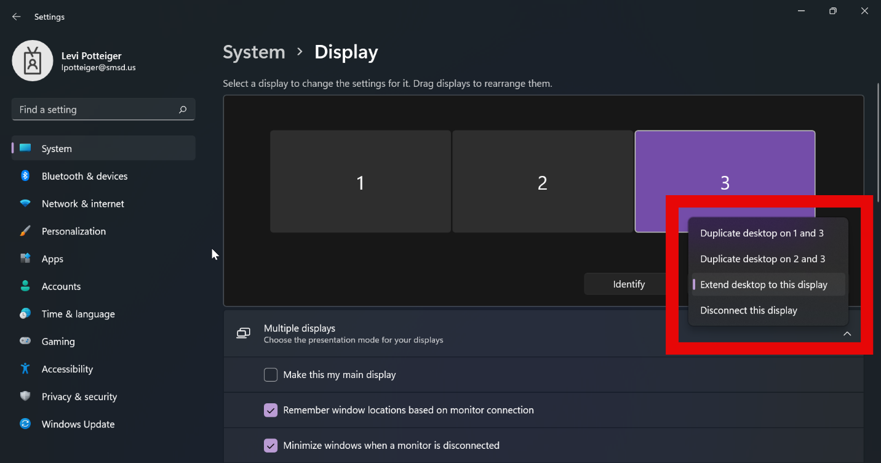
Please note that duplicating or undoing a duplication may change the default display.

